Martech SHOP | Contact us | Profil | Registration | Log out [ alkom ]
Martech FORUM | Forum FAQ | Search | Groups | You have no new messages

How to connect and use MARTECH (box, TPAdapter)

Forum MARTECH GSM FORUM Strona Główna -> SIEM Service Tools - Technical Support (POLISH LANG ONLY // JĘZYK POLSKI)

See previous topic : See next topic
Autor | Message
MARTECH SUPPORT  Martech Team Member  Dołączył: 19 Lis 2004  Posty: 135
  Posted: SRO Feb 01, 2006 6:27 pm Post subject: How to connect and use MARTECH device (box, TPAdapter)
  How to use box II Plus Alu with Testpoint adapter v2.0/ v3.0...
  The set includes:
  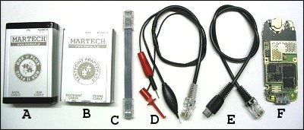
  A - Martech box II PLUS Alu
  B - Testpoint Adapter v3.0
  C - Tape connecting Martech box with TP adapter
  D - Testpoint cable
  E - Transmission cable (direct cable) for phone
  F - Phone plate
  How to connect box II PLUS set (phones series EGOLD):
  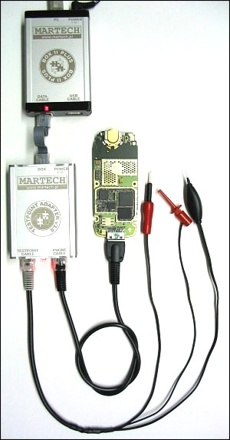
  how to use MARTECH SIEM Service Tools with box II PLUS
  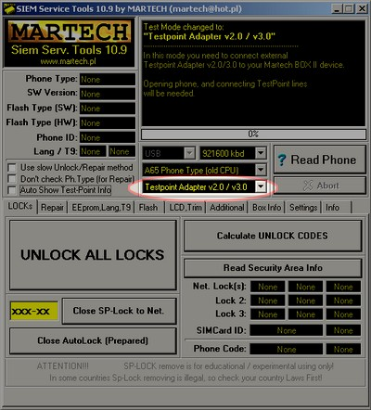
  - run the latest version of Martech SIEM Service Tools
  - select
  the phone type - select the mode "Testpoint Adapter v2.0/ v3.0"
  - click on any function (e.g. "Read Phone" button)
  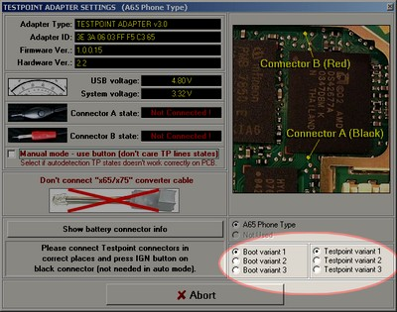
  - look at the photo with marked test points
  - check the phone's power connection (red connector)
  - select the correct BOOT/testpoint variant (variant 1 is selected by default)
  - touch the needles to the points on the phone
  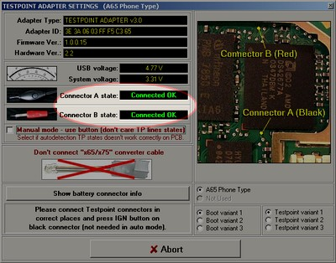
  the status of touching the needles to the points will be shown in the "Connector State" area
  If the states of both needles indicate "connected OK", then the application will automatically start the process of connecting to the phone...
  Hold the test point needles until the application allows you to disconnect them from the points on the phone board.
  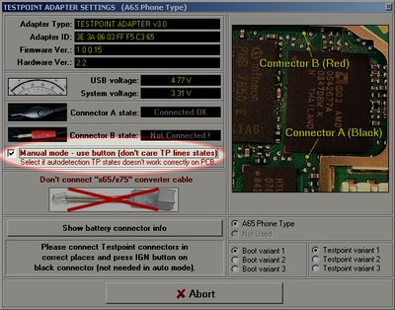
  If you have a problem with self-detection - just select "Manual mode", touch the needles for test points and press the button on the black probe...
  Some older EGOLD series phones do not require the use of test points. You can connect to them in "DIRECT mode", so always try to connect to your phone in DIRECT mode... In case of failure, open the phone and use Testpoint adapter...
  How to connect box II PLUS (SGOLD series phones):
  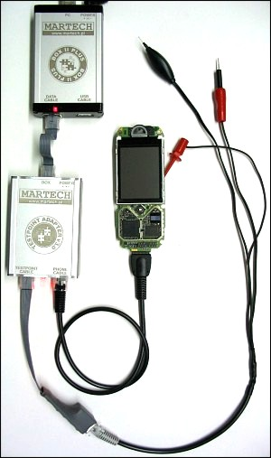
  For SGOLD phones it is required to use an additional x65/X75 grommet!
  How to use MARTECH SIEM Service Tools with box II PLUS
  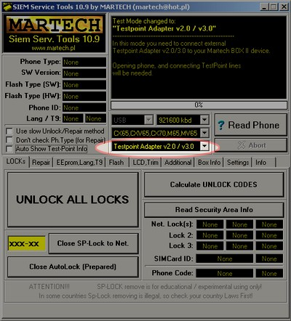
  - run the latest version of Martech SIEM Service Tools
  - select
  the phone type - select the mode "Testpoint Adapter v2.0/ v3.0"
  - click on any function (e.g. "Read Phone" button)
  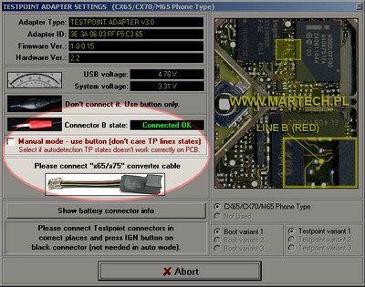
  - look at the photo with marked test points
  - check the phone's power connection (red connector)
  - select the correct BOOT/testpoint variant (variant 1 is selected by default)
  - touch the needles to the points on the phone board
  the status of the touch of the needle to the point will be shown in the "Connector State" area
  If the needle state indicates "connected OK", then the application will automatically start the process of connecting to the phone...
  For S65,SV65,S66,SK65,CX75,M75,CF75, you must use manual mode (for these phones this mode is selected by default). "Manual mode" requires the use of a button on the black probe...
  Remember, with "older" SGOLD phones (with SW versions lower than 36), you can work in DIRECT mode (without testpoints).
  Use a fully charged battery...
  *********************************************************************
  How to use box LITE with Easy Adapter...
  Set includes:
  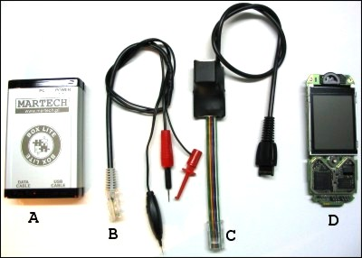
  A - Martech box LITE
  B - Testpoint Cable
  C - Easy Adapter
  D - Phone SGOLD series
  How to connect box LITE set:
  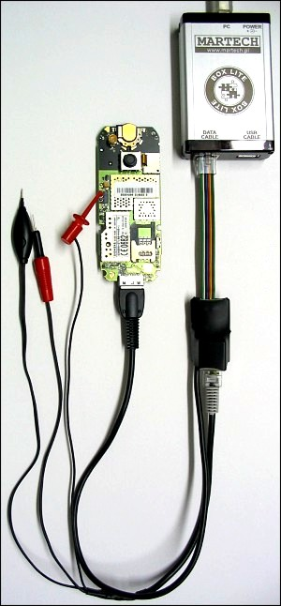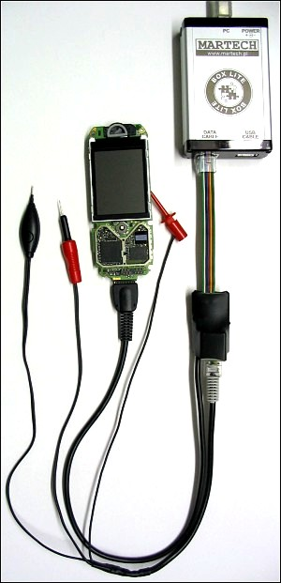
  how to use MARTECH SIEM Service Tools with box LITE
  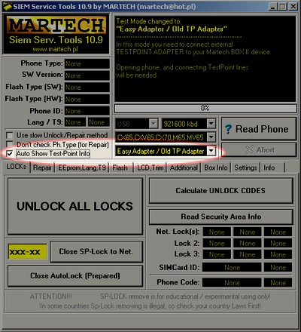
  - run the latest version of Martech SIEM Service Tools
  - select
  the phone type -
  select the mode "EasyAdapter/ Old TP Adapter" - check "Auto Show Test-Point Info
  " - click on any function (e.g. "Read Phone" button)
  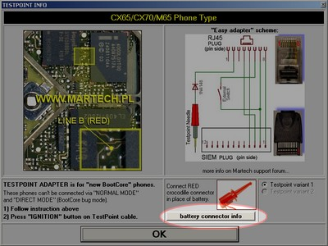
  - look at the photo with the marked test point
  - check the phone power connection (red connector)
  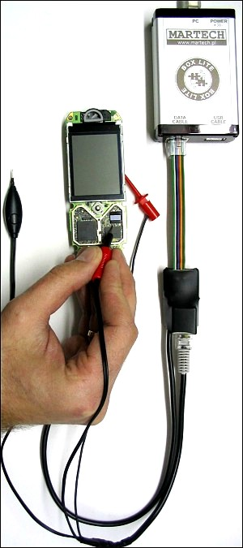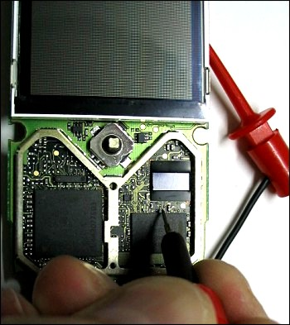
  - touch the needle to the point on the phone plate
  - press the button on the black probe
  Remember, with "older" SGOLD phones (with SW versions lower than 36), you can work in DIRECT mode (without testpoints).
  Use a fully charged battery...
  Good luck!
Back to top
View recent Posts:

 | Forum MARTECH GSM FORUM Strona Główna -> SIEM Service Tools - Technical Support (POLISH LANG ONLY // JĘZYK POLSKI) | All times in EET zone (Europe)
Page 1 of 1

Follow the answers on this topic | Start of the form  You can write new topics.you can answer  in topics.you can change  your postsDo not remove your postsYou can vote  in surveys
  Jump to:
Powered by phpBB © 2001, 2005 phpBB Group

